Joining Skype meeting in a group with a conference phone & device
On your device (Laptop/PC/Tablet)  To see the presentation:  In the meeting request click “Join Skype Meeting” | 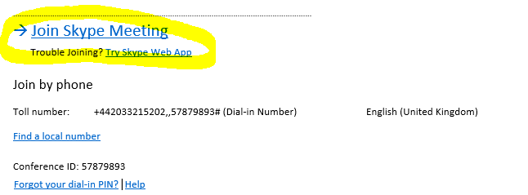
How to avoid feedback between phone and device  If you get this screen, choose “Don’t join audio”  This will disable the audio on your device so that you can use the audio on your conference phone without sound feedback. | 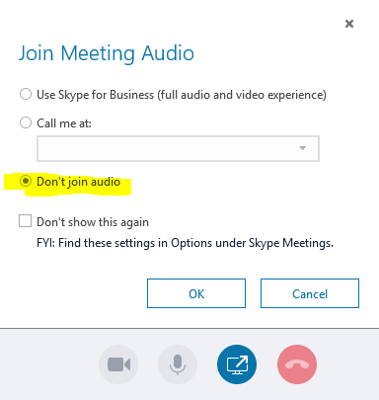
Join the audio via the Conference phone:  Call the Toll number on your meeting request and enter the Conference ID  You will enter the meeting muted but will be able to unmute yourself. | 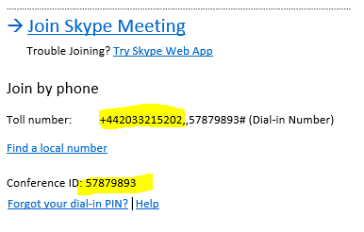
Meeting Helpful Hints | You will be automatically muted when you join the meeting.  You can unmute yourself by selecting the unmute on your conference phone.  If you would like to message the presenter, please use the instant message feature on your device by selecting this button within the meeting

