Joining the meeting via the Skype for Business (SfB) link
How to join the meeting.  Select the Skype link available on the website  If you have SfB installed, you can join using the installed app.  If you do not have SfB installed, you can still join be using the web app. | 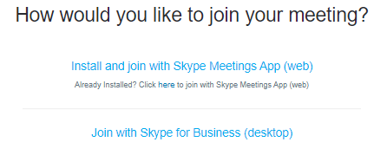
Checking audio settings

You can select the circles ellipses to ensure your speakers are working prior to joining the meeting.
Muted in the meeting

All attendees are muted when they join. Select the audio option to unmute.
Meeting Helpful Hints | If you would like to message the presenter, please use the instant message feature on your device by selecting this button within the meeting.  Please Note: messages can be seen by all participants.

